Data Mining Assignment 3

1) Read Chapter 6 (only sections 6.1 and 6.7).  
  
2) Do Chapter 6 textbook problem #2 (parts a,b,c,d only) on page 404.

Consider the data set shown in Table 6.1.

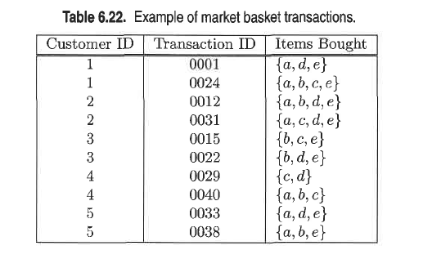

(a) Compute the support for itemsets *{e}*, *{b, d}*, and *{b, d, e}* by treating

each transaction ID as a market basket.

*s*(*{e}*) = 8/10 = 0.8

*s*(*{b, d}*) = 2/10 = 0.2

*s*(*{b, d, e}*) = 2/10 = 0.2

(b) Use the results in part (a) to compute the confidence for the association

rules *{b, d} −→ {e}* and *{e} −→ {b, d}*. Is confidence a symmetric measure?

*c*(*bd 🡪 e*) = 0.2/0.2 = 100%

*c*(*e 🡪 bd*) = 0.2/0.8 = 25%

No, confidence is not a symmetric measure.

(c) Repeat part (a) by treating each customer ID as a market basket. Each

item should be treated as a binary variable (1 if an item appears in at

least one transaction bought by the customer, and 0 otherwise.)

*s*(*{e}*) = 4/5 = 0.8

*s*(*{b, d}*) = 5/5 = 1

*s*(*{b, d, e}*) = 4/5 = 0.8

(d) Use the results in part (c) to compute the confidence for the association

rules *{b, d} −→ {e}* and *{e} −→ {b, d}*.

*c*(*bd 🡪 e*) = 0.8/1 = 80%

*c*(*e 🡪 bd*) = 0.8/0.8 = 100%  
  
3) Do Chapter 6 textbook problem #6 (parts d,e only) on page 406.

Consider the market basket transactions shown in Table 6.23.

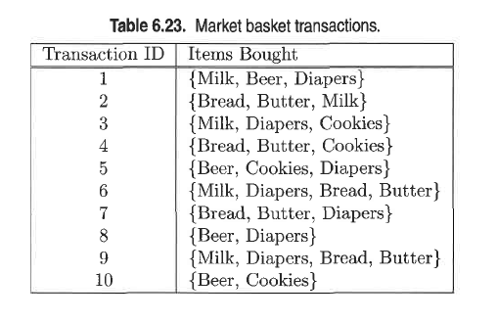

(d) Find an itemset (of size 2 or larger) that has the largest support.

*{*Bread, Butter*}*.

(e) Find a pair of items, *a* and *b*, such that the rules *{a} 🡪 {b}* and

*{b} 🡪 {a}* have the same confidence.

(Beer, Cookies) or (Bread, Butter).  
  
4) Using the data at [www.stats202.com/more_stats202_logs.txt](http://www.stats202.com/more_stats202_logs.txt) and treating each row as a "market basket" compute the support and confidence for the rule ip=65.57.245.11 → "Mozilla/5.0 (X11; U; Linux i686 (x86_64); en-US; rv:1.8.1.3) Gecko/20070309 Firefox/2.0.0.3".

State what the support and confidence values mean in plain English in this context.